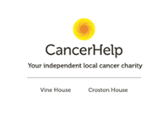

JOB ADVERT
Communications & Income Generation Officer (Part-Time)
Location: Preston, Lancashire
Part time hours: 21 hours a week
Fixed term: Initially for 6 months
Rate of pay: Circa £35k (WTE) £20k pro rata
CancerHelp (Preston) Ltd is a local charity providing free support to people affected by cancer. We are seeking a talented and motivated Communications & Income Generation Officer to help us grow and secure vital funding for our services.
This is an exciting opportunity for someone with strong bid writing and campaign management experience who wants to play a key role in sustaining and developing local cancer support services in a well established charity.

What You will Do:
- Write compelling grant and trust funding applications
- Lead fundraising and awareness campaigns
- Develop engaging supporter communications
- Help grow and diversify our income streams

What We are Looking For:
- Proven bid writing success
- Strong communication and storytelling skills
- Experience in fundraising or charity communications
- Ability to work independently in a part-time role

Why Join Us?
- Flexible, part-time hours
- Meaningful, mission-driven work
- Opportunity to shape and grow the role
- Supportive and passionate team environment
If you are passionate about making a difference and have the skills to help us secure funding and grow our reach we would love to hear from you.
To apply:
For an informal chat please contact the Team at Vine House on either (01772) 793344 or info@cancerhelppreston.co.uk and either ask for or mark FAO Jeanette Smalley.
If you wish to apply, in the first instance, please submit your CV and a brief covering letter outlining your relevant experience.

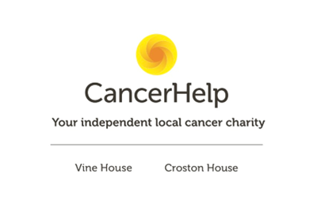
Job Description - Communications & Income Generation Officer (Campaigns & Bid Writing)

Reporting To: General Manager
Location: Vine House, Ribbleton, Preston, Lancashire with the occasional home working option

Hours: Part-time (21 hours per week – flexible working considered)

Contract: Fixed term initially – 6months

Rate of pay: negotiable (WTE circa £35k, approx. £20k for 21 hours a week)

Job Purpose
To lead and develop communications and income generation activity at CancerHelp Preston Ltd, with particular focus on fundraising campaigns, grant and trust bid writing, donor communications, and supporter engagement.
This role will strengthen the charity’s visibility, diversify income streams, and secure funding to ensure the continuation and development of CancerHelp’s cancer support services.

Key Responsibilities

Income Generation & Fundraising
- Research and identify suitable grant and trust funding opportunities
- Write and submit compelling funding applications and bids
- Develop and manage a fundraising pipeline and calendar
- Produce timely and accurate funding reports for funders
- Support the development of corporate partnerships and community fundraising
- Work with the leadership team to identify new income opportunities

Campaigns & Communications
- Plan and deliver fundraising and awareness campaigns
- Develop engaging content for website, email newsletters, and social media
- Manage and grow supporter communications
- Produce impact stories, case studies, and donor updates
- Ensure consistent messaging and brand voice across channels

Marketing & Engagement
- Increase community awareness of CancerHelp Preston’s services
- Support event promotion and donor stewardship
- Maintain and update website content
- Track and report on campaign performance and engagement metrics

General
- Maintain accurate records of applications, donors, and communications
- Ensure compliance with GDPR and fundraising regulations
- Represent the charity at events and networking opportunities
- Undertake any other duties appropriate to the role

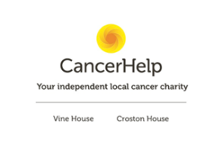

PERSON SPECIFICATION
 | Essential Criteria | Desirable Criteria

Experience
 | Proven experience in grant/trust bid writing | Experience measuring impact and writing evaluation reports
 | Experience in fundraising and income generation
 | Experience managing communications or marketing campaigns
 | Experience working within the charity or voluntary sector
 | content creation skills and ability to use Canva or similar tool for design work
 | Experience developing corporate partnerships

Skills & Knowledge
 | Excellent written communication and storytelling skills | Knowledge of local funding landscape in Lancashire
 | Ability to write persuasive, compelling funding applications
 | Strong research and analytical skills
 | Ability to manage multiple deadlines independently
 | Digital communications skills (social media, email marketing, website CMS)
 | Understanding of donor stewardship and relationship management

Personal Attributes
 | Self-motivated and proactive – ability to work independently with minimal supervision
 | Highly organised with strong attention to detail
 | Creative thinker with campaign ideas
 | Empathetic and aligned with the values of a cancer support charity
 | Comfortable working in a small team environment where individuals take responsibility for a wide range of activities
 | Able to work effectively without extensive support structures
 | Able to work autonomously and manage all aspects of the role including routine and administrative tasks

Additional
 | Current clean driving licence
 | Ability to support occasional events at weekends / evenings

